James Keith and Boone Tison

Homework #3

1. The base of the log does not matter as they are all in the same family in regards to algorithm analysis. The best base for us is log base 2 because that is what computer scientists use the most.
2. Slope: b Y-intercept: a
3. 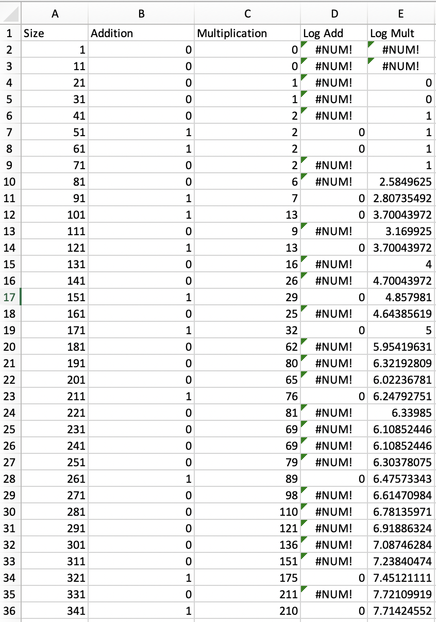

7. The slopes are both small because addition and multiplication are quick operations. Although, multiplication has a larger slope because the operation takes more time, so this does align with the theoretical algorithm efficiency.

8. Both experiments can be run with ever increasing size. You could also mess with matrices of different sizes, as long as one’s columns matches the other rows, for multiplication. Another option is to use larger numbers being operated on.

9. The log log analysis allows the user to separate the n^2 from the log n and see which part of the algorithm is increasing faster. It also stays in the same form as the change of base formula.

|  |  |  |
| --- | --- | --- |
|  | Matrix Addition | Matrix Multiplication |
| Slope coefficient | 0.0004 | 0.0116 |
| Y-Intercept | -0.116 | 2.7409 |
| Line of best fit | Y = 0.0004x – 0.116 | Y = 0.0116x + 2.7409 |